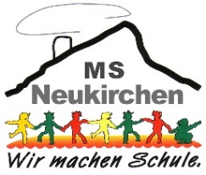

Mittelschule Neukirchen Bahnhofstraße 10, 4872 Neukirchen a.d.V.

◼ 🕾 07682 7631 (Fax: DW 4) ◼ E-Mail: msneukirchen@eduhi.at ◼ www.msneukirchen.net ◼

Entschuldigung

◼◼◼◼◼◼◼◼◼◼◼◼◼◼◼◼◼◼◼◼◼◼◼◼◼◼◼◼◼◼◼◼◼◼◼◼◼◼◼◼◼◼◼◼◼◼◼◼◼◼◼◼◼◼◼◼◼◼◼◼◼◼◼◼◼◼◼

Mein Sohn / Meine Tochter …………………………………………………

konnte am .................................... die Schule nicht besuchen.

Begründung:

………………………………………………………………………………..….….…

……………………………………………………………………………………….…

**Unterschrift:** ……………………………………..

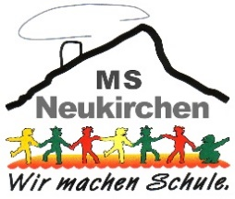

◼ 🕾 07682 7631 (Fax: DW 4) ◼ E-Mail: msneukirchen@eduhi.at ◼ www.msneukirchen.net ◼

Mittelschule Neukirchen Bahnhofstraße 10, 4872 Neukirchen a.d.V.

◼◼◼◼◼◼◼◼◼◼◼◼◼◼◼◼◼◼◼◼◼◼◼◼◼◼◼◼◼◼◼◼◼◼◼◼◼◼◼◼◼◼◼◼◼◼◼◼◼◼◼◼◼◼◼◼◼◼◼◼◼◼◼◼◼◼◼

**Unterschrift:** …………………………..…………

Mein Sohn / Meine Tochter …………………………………………………

konnte am .................................... die Schule nicht besuchen.

Begründung:

……………………………………………………………………………..…..………

……………………………………………………………………………….…………

◼◼◼◼◼◼◼◼◼◼◼◼◼◼◼◼◼◼◼◼◼◼◼◼◼◼◼◼◼◼◼◼◼◼◼◼◼◼◼◼◼◼◼◼◼◼◼◼◼◼◼◼◼◼◼◼◼◼◼◼◼◼◼◼◼◼◼

◼◼◼◼◼◼◼◼◼◼◼◼◼◼◼◼◼◼◼◼◼◼◼◼◼◼◼◼◼◼◼◼◼◼◼◼◼◼◼◼◼◼◼◼◼◼◼◼◼◼◼◼◼◼◼◼◼◼◼◼◼◼◼◼◼◼◼

◼◼◼◼◼◼◼◼◼◼◼◼◼◼◼◼◼◼◼◼◼◼◼◼◼◼◼◼◼◼◼◼◼◼◼◼◼◼◼◼◼◼◼◼◼◼◼◼◼◼◼◼◼◼◼◼◼◼◼◼◼◼◼◼◼◼◼

Entschuldigung